Introduction
The efficient transmission of electrical power over long distances is a critical aspect of modern electrical power systems. High voltage transmission lines are employed to transport electricity from power generation plants to distribution networks and end-users. However, as power travels through these transmission lines, various phenomena can affect the overall performance of the system. One such phenomenon that demands careful consideration is the Ferranti Effect.
Ferranti Effect refers to the phenomenon where the voltage at the receiving end of a transmission line is higher than the voltage at the sending end when the line is lightly loaded or under no load conditions. This counterintuitive effect can have significant implications for the design, operation, and protection of power systems. This effect is primarily attributed to the capacitance of the transmission line, which causes voltage magnification as the line length increases.
This laboratory experiment aims to investigate the Ferranti Effect on transmission lines and explore its impact on voltage regulation under various loading conditions. We will analyse how different parameters, such as line length, capacitance, and load conditions, influence the magnitude of the Ferranti Effect. The experimental setup will include a scaled-down model of a transmission line, allowing for systematic observations and measurements.

Theory
The Ferranti Effect on transmission lines is a phenomenon that arises due to the distributed capacitance of the line. This effect becomes particularly noticeable when the transmission line is lightly loaded or under no-load conditions. The theory behind the Ferranti Effect can be explained through the following key concepts:

Capacitance of Transmission Lines:
  - Transmission lines inherently possess capacitance between the conductors and the surrounding ground. This capacitance allows the line to store electrical energy in the form of an electric field between the conductors.
  - The capacitance is distributed along the entire length of the transmission line and is influenced by factors such as the spacing between conductors and the surrounding medium.

Voltage Distribution and Phase Shift:
  - When electrical power is transmitted over a long-distance transmission line, the distributed capacitance causes a phase shift between the voltage and current along the line.
  - Capacitive reactance leads to a lagging power factor, causing the current to lag behind the voltage in the transmission line.

Voltage Magnification:
  - Under no-load or light-load conditions, where the current flowing through the transmission line is relatively small, the capacitive reactance dominates the impedance of the line.
  - The voltage drop across the inductive (resistive) components is small compared to the voltage drop across the capacitive reactance. As a result, the voltage at the receiving end of the line is higher than the voltage at the sending end.
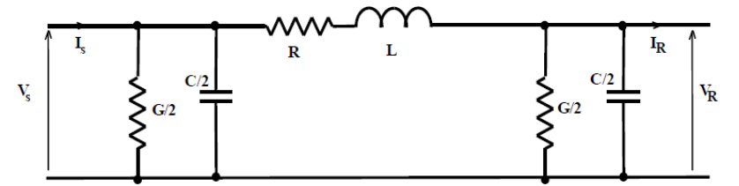
Fig. 1 Line diagram of a transmission line
- Ferranti Effect Equation:
  - The Ferranti Effect can be quantified by the Ferranti Effect equation:
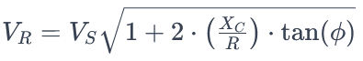
  - ​
Where:
    - VR​ is the receiving end voltage.
    - VS​ is the sending end voltage.
    - XC​ is the capacitive reactance of the transmission line.
    - R is the resistance of the transmission line.
    - ϕ is the phase angle between voltage and current.
- Conditions for Ferranti Effect:
  - The Ferranti Effect becomes more pronounced as the length of the transmission line increases.
  - It is more noticeable at higher transmission voltages.
  - The effect is more significant for lightly loaded or no-load conditions.

Objectives
The objectives of the laboratory experiment on the Ferranti Effect on transmission lines are as follows:
- Investigate Ferranti Effect Magnitude:
  - Measure and quantify the Ferranti Effect on a scaled-down transmission line under varying load conditions to understand how voltage magnification occurs.
- Explore Line Length Influence:
  - Examine the impact of varying the length of the transmission line on the Ferranti Effect, aiming to determine the relationship between line length and voltage amplification.
- Analyse Capacitance Effects:
  - Investigate how changes in the capacitance of the transmission line affect the Ferranti Effect, providing insights into the role of line capacitance in voltage regulation.
- Examine Load Conditions:
  - Study the Ferranti Effect under different load scenarios, ranging from no-load to full load, to observe how the phenomenon responds to varying levels of power demand.

Procedure
Baseline Measurements:
- Apply a no-load condition to the transmission line by disconnecting the load resistor.
- Measure and record the sending end voltage (VS​) and the receiving end voltage (VR​) using the calibrated instruments.
- Record the current (I) flowing through the transmission line.
- Calculate the power factor angle (ϕ) using the measured voltage and current.
Varying Load Conditions:
- Gradually increase the load by adjusting the variable load resistor while maintaining constant voltage at the sending end.
- At each load increment, record VS​, VR​, and I.
- Calculate the power factor angle (ϕ) for each load condition.
Varying Line Length:
- adjust the length of the transmission line.
- Repeat the experiment steps under different line length conditions, measuring and recording VS​, VR​, and I.
Student will vary the load and line length
Table I
SN | Distance (Km) | Sending End Voltage | Sending End Current | Receiving End Voltage | Receiving End Current
1 | 30 | 90V | 0.2A | 90V | 0.06A
2 | 60 | 90V | 0.2A | 90V | 0.06A
3 | 90 | 90V | 0.2A | 91V | 0.06A
4 | 120 | 90V | 0.2A | 91V | 0.06A
5 | 150 | 90V | 0.2A | 94V | 0.06A
6 | 180 | 90V | 0.2A | 96V | 0.06A
7 | 210 | 90V | 0.2A | 100V | 0.06A
8 | 240 | 90V | 0.2A | 104V | 0.06A
9 | 270 | 90V | 0.2A | 108V | 0.06A
10 | 300 | 90V | 0.2A | 113V | 0.07A
11 | 330 | 90V | 0.2A | 122V | 0.07A
12 | 360 | 90V | 0.2A | 131V | 0.07A

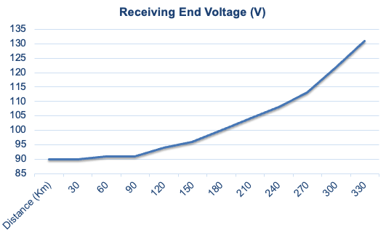
Fig. 2 Change in receiving end voltage with distance
The graph shows a curve that represents the relationship between the distance of the transmission line (in kilometers) on the x-axis and the receiving end voltage (in volts) on the y-axis.
The Ferranti Effect is characterized by an increase in voltage at the receiving end of a transmission line compared to the sending end, especially noticeable as the line length increases. This increase in voltage is due to the capacitive properties of the transmission line acting when there is a light load or open-circuited condition at the receiving end.
From the graph, it is evident that:
For shorter distances (from 0 to approximately 150 km), the receiving end voltage remains relatively close to the baseline, indicating that the Ferranti Effect is not pronounced.
As the distance increases beyond 150 km, there is a noticeable upward curve, which becomes more pronounced as the distance reaches towards 400 km. This shows a significant increase in the receiving end voltage, which is characteristic of the Ferranti Effect.
The voltage starts at just above 100 volts at 0 km and rises sharply after about 250 km, reaching upwards of 130 volts near 400 km.
This graph is a typical representation of the Ferranti Effect and provides a visual understanding of how transmission line length affects the receiving end voltage in a high-voltage AC transmission system.
Analysis and Conclusion:
- Analyze the data to observe the receiving-end voltage under different line length conditions.
- Plot graphs to visualize the relationship between receiving-end voltage and line length.
- draw conclusion regarding how Ferranti effect affects receiving end voltage and what are it’s implications for power systems.
- Discuss potential strategies for mitigating the Ferranti Effect and improving voltage regulation in practical transmission systems.

References
https://vp-dei.vlabs.ac.in/Dreamweaver/proce9.html
https://core.ac.uk/reader/329119563
https://www.studocu.com/in/document/amrita-vishwa-vidyapeetham/power-systems-lab/power-system-lab-experiment-5/24396931
https://www.youtube.com/watch?v=7JNJ7xOXlgM

